**Report and Result for Lung’s cancer prediction**

**Result:**

Using a dataset focused on Lung’s cancer assessment, this study demonstrates the construction of a predictive model to determine Lung cancer prediction. The dataset includes measurements such as gender, age, smoking, yellow fingers, anxiety, peer pressure, chronic disease, fatigue, allergy, wheezing, alcohol consuming, coughing, shortness of breath, swallowing difficulty, chest pain, lung cancer with each sample indicating whether the Lung’s cancer is there or not. After preprocessing steps including handling missing values and various machine learning methods, a Logistic Regression was employed. The model was evaluated on a test set, yielding an accuracy of 93.07%, indicating a strong ability to correctly identify lung cancer prediction, the recall was notably low at 50.11%, suggesting a limitation in capturing all potable cases. This resulted in an F1-score of 62.38%, reflecting the balance between precision and recall. These results highlight the model's capabilities and limitations, suggesting areas for further refinement, especially in improving recall to ensure more comprehensive identification of Lung cancer. This analysis is crucial for Lung Cancer identification.

**Model Comparison:**

| S.No | Model | Test Accuracy |
| --- | --- | --- |
| 1 | Decision Tree Classifier | 8.23 |
| 2 | Random Forest Classifier | 26.91 |
| 3 | Artificial Neural Network | 18.34 |
| 4 | K Nearest Neighbours | 89.33 |
| 5 | Logistic Regression | 93.07 |

**Countplot:**

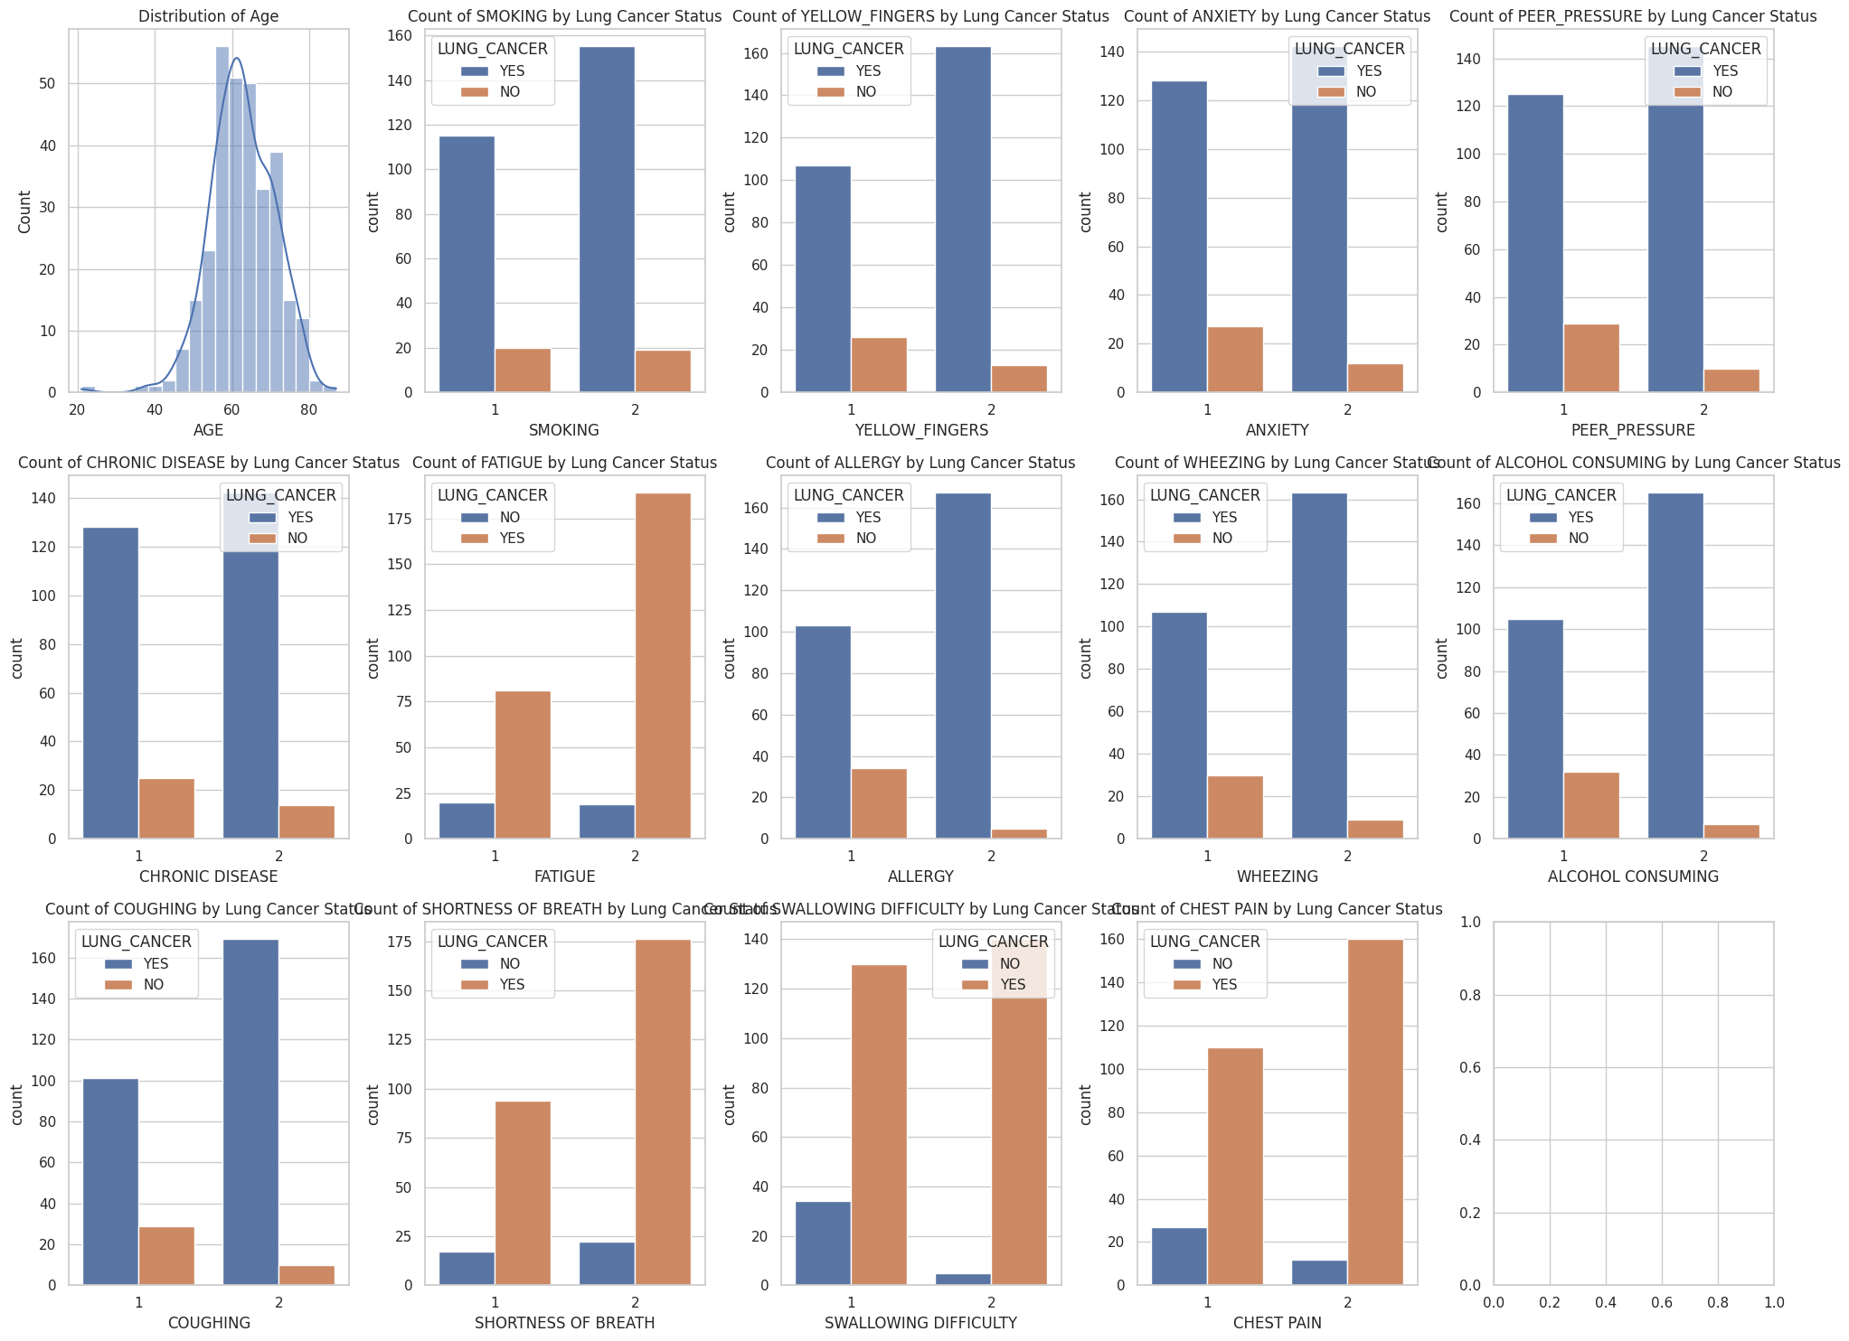

**Histogram:**

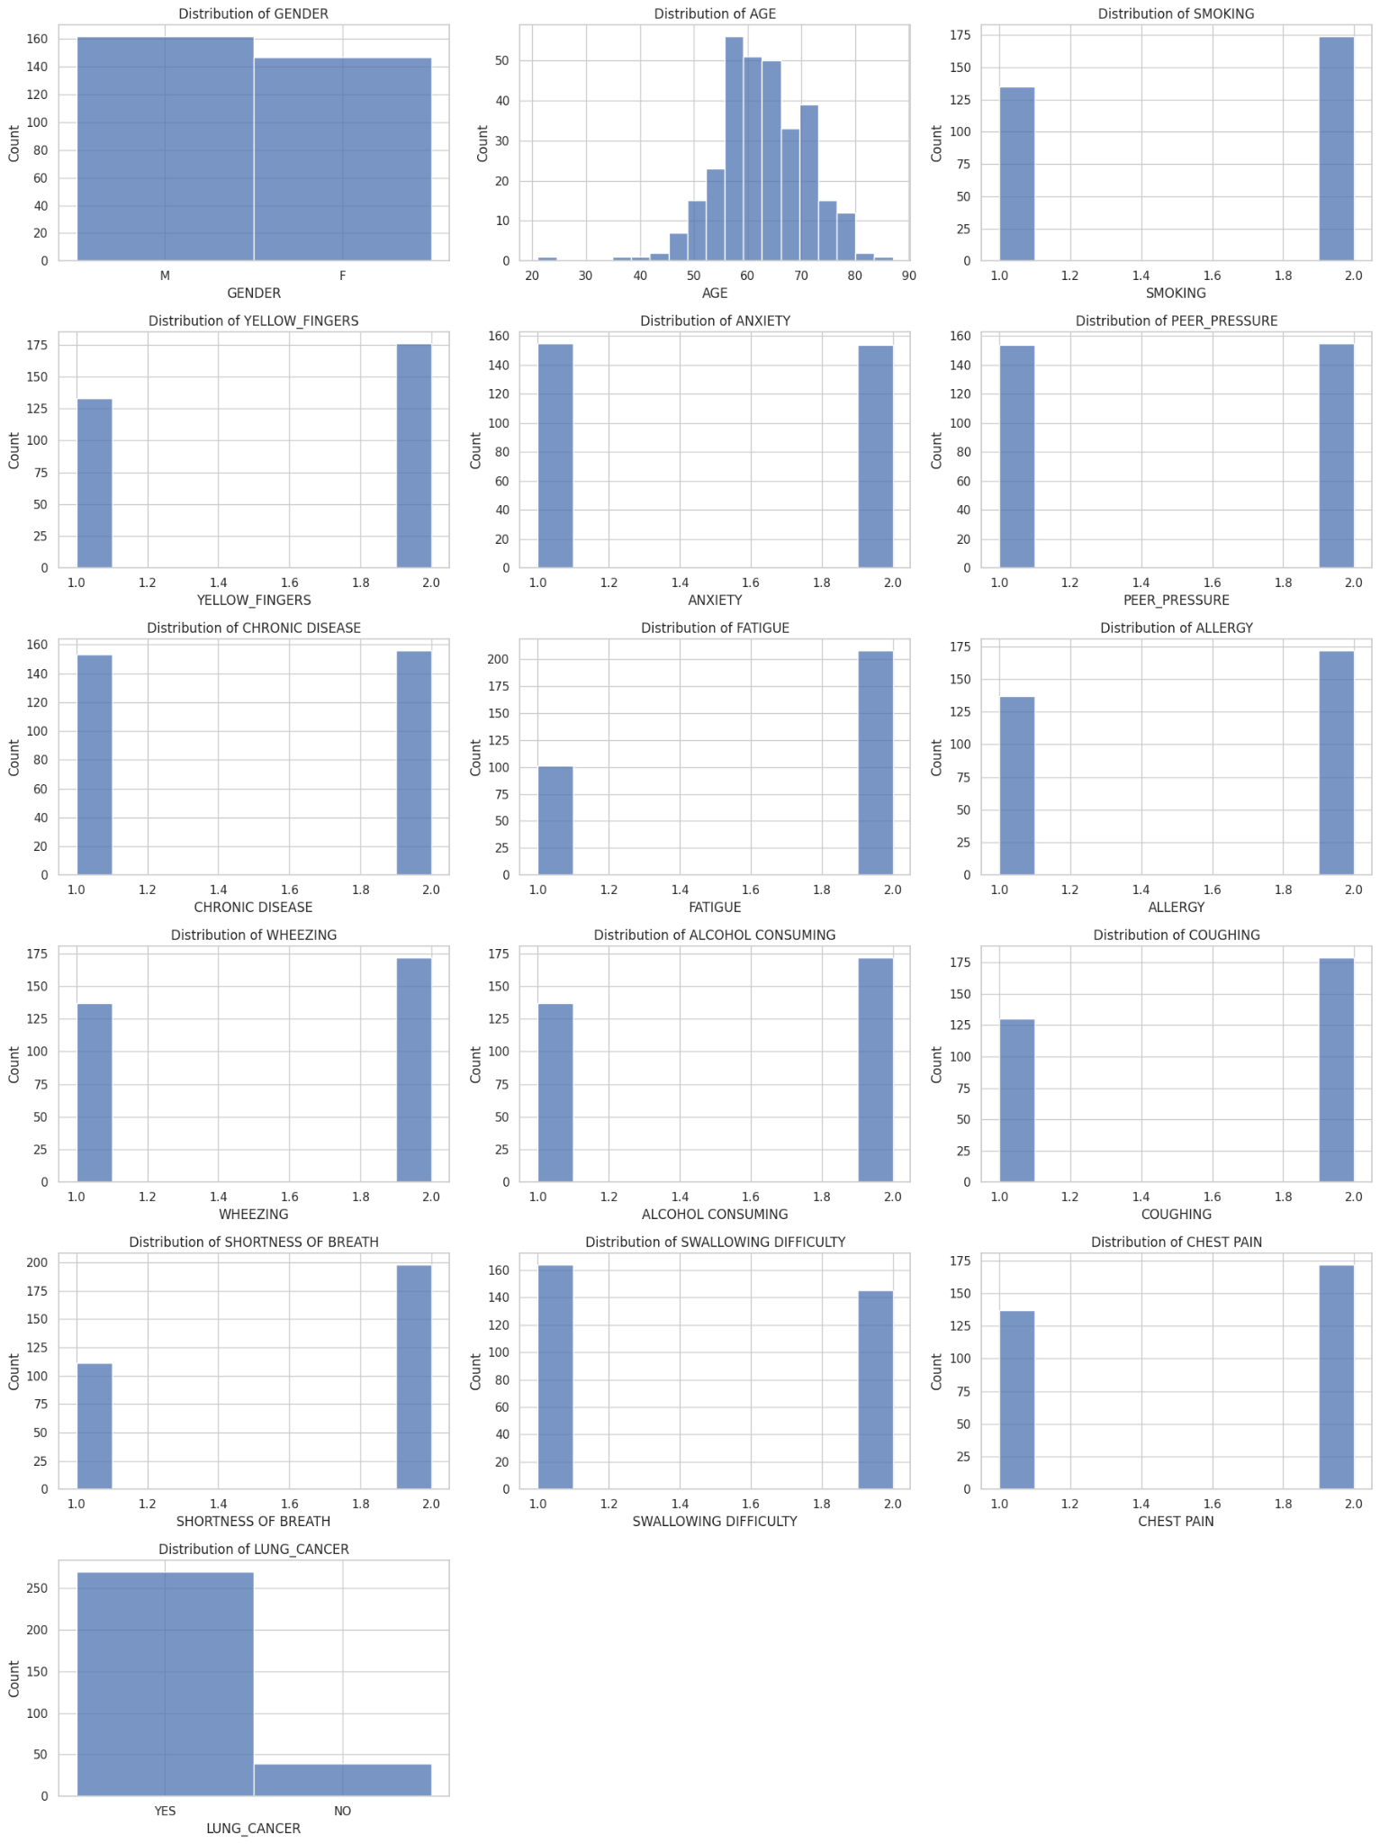

**Correlation Matrix using Heatmap:**

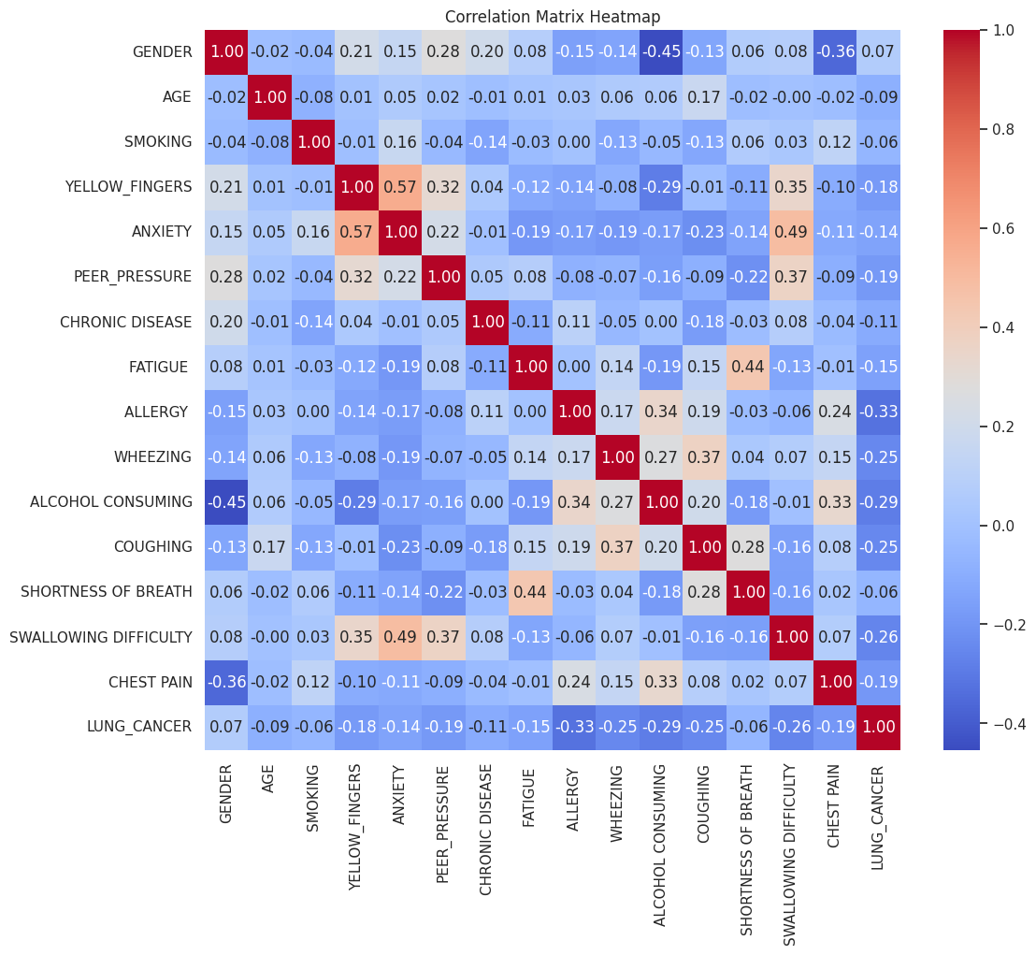

**Confusion Matrix for the Logistic Regression model:**

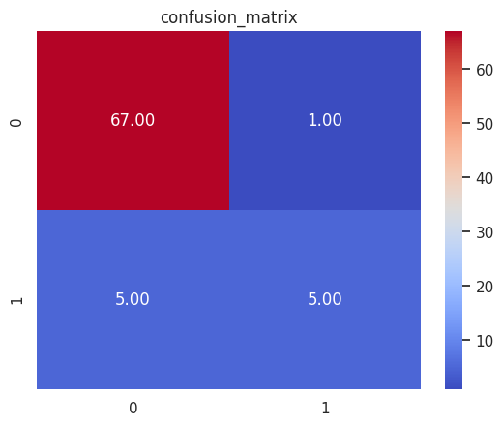

**Roc Curve:**

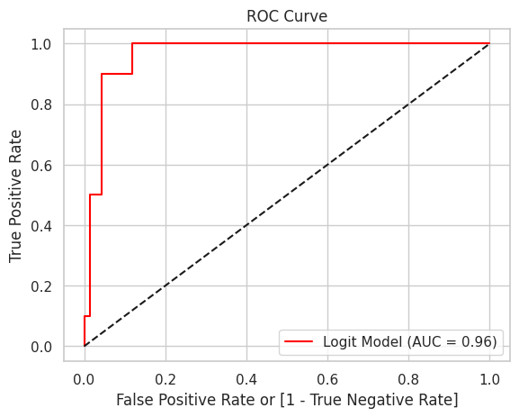

**Classification Report using Heatmap:**

